* Issue with the web application due to IIS service is not started
* below error received,while starting the IIS service

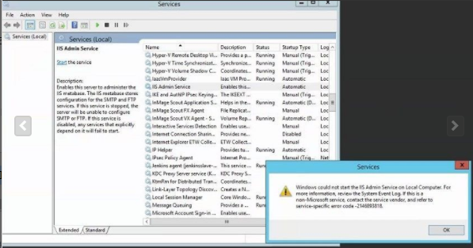

* Troubleshooted the error with reference to below Microsoft site

<https://techcommunity.microsoft.com/t5/iis-support-blog/error-2146893818-event-7024-invalid-signature/ba-p/1074715>

* Error occurs when the machine key which is used for decryption/encryption is corrupted
* Remove the machine key starting with c23 (C:\ProgramData\Microsoft\Crypto\RSA\MachineKeys)
* Uninstall IIS 6 Metabase Compatibility (Server Manager > Manage > Remove Roles and Features) and restarted the server
* After restarting the server, install IIS 6 Metabase Compatibility (Server Manager > Manage > Add Roles and Features). Make sure that the machine key with c23 name is created
* Go to Services window. IIS Admin Service should already running.

Attached the screenshot below

